

Art & DT Curriculum


ART & DT CURRICULUM
Intent
At Cherry Tree, our Art and DT programme of study links across curricula to complement pupils’ wider understanding of topics and concepts. Learning is structured to ensure that pupils develop a deep understanding of:
- Practical skills of art and design – concentrating on method and technique;
- Theoretical knowledge of art – including the history of art;
- Traditional, modern and contemporary paradigms of art.

Moving away from our previous curriculum of simply imitating art, our new curriculum aims to support pupils in critically evaluating artists and their work. This is achieved through debate and dialogue about technique, perspective and methods used.

The planning, amended from Lion Pathways, maps all objectives from the National Curriculum to ensure that progression is clear from EYFS to Year 6.
Pupils are encouraged to build on their developing knowledge in other subject areas. For example – pupils studying the Bronze Age in Year 1, create cuneiform tablets in Art as they develop an understanding of the ancient form of writing. It is through this cross-curricula study that pupils develop wider schema links.

Moving away from performance outcomes

What you will not see in Cherry Tree’s pupils’ sketchbooks is a mimicked drawing each lesson that attempts to recreate the work of a famous artist.
Lessons are designed to enrich our pupils’ understanding of the process of art as well as developing their knowledge of the history of artists and their time. To this end, some lessons are focused more on discussion and appreciation – with pupils reflecting on what they do or do not like about methods artists use. Once pupils have this deeper background knowledge, teachers will explore the skills and techniques – with children able to experiment, test out and create.

Planning

At Cherry Tree we know that presenting pupils with facts in a way that is disconnected and disordered leads to cognitive dysfluency. Pupils find it difficult to connect schema over time and this leads to knowledge and skill deficits which can hinder progress at the end of key stages.
Planning is explicit and the lesson visuals support pupils emerging language development – with key word banks presented at the very beginning of each lesson. This enables our pupils to use the language of art and design appropriately and with increasing accuracy.

Implementation
“Art offers sanctuary to everyone willing to open their hearts – as well as their eyes”
Nikki Giovannix

Experiential learning

Cherry Tree serves a diverse pupil population and many of our children speak English as an additional language. To ensure that pupils can progress, a heavy emphasis is placed on language and terminology study. Lessons begin with word banks and visual representations to support cognitive understanding.
Component lessons, in a unit sequence, end with a composite task. These range from:
- Class design tasks – such as mosaic making to create a class display
- Design tech composite tasks such as sculpture exhibitions
- Writing – pupils using artists work as a muse to write stories or to interpret feeling.

Showcasing our knowledge and learning- Home Learning
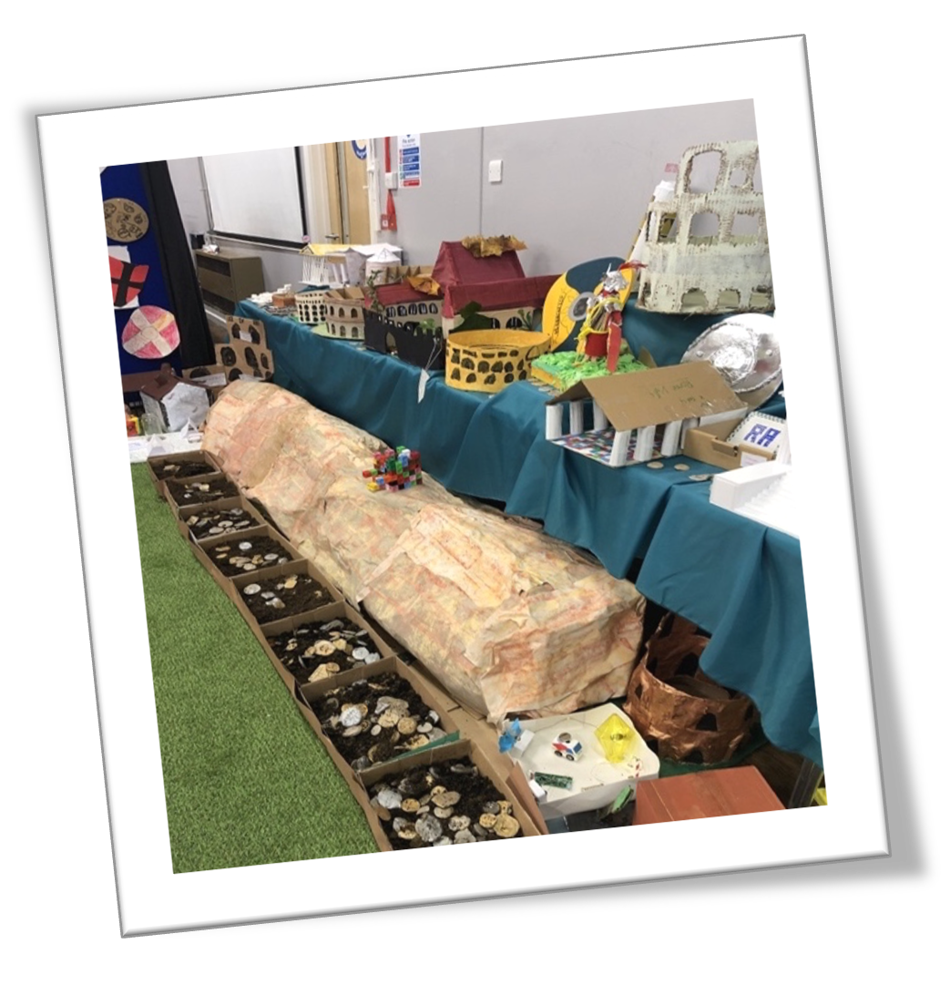
At the beginning and end of each term, pupils are set a home learning task linked to the art topic or artist being studied in class. These tasks provide opportunities for pupils to develop and apply their creative skills, explore a range of techniques and materials, and respond thoughtfully to the work of artists and designers. Pupils are encouraged to express their ideas and creativity, building confidence and cultural capital through engagement with the visual arts. Completed work is celebrated and displayed in classrooms, recognising effort, originality, and achievement. This approach enables pupils of all abilities to showcase their learning in a format that reflects their individual strengths, interests, and preferred ways of working.

Assessing pupil progress in Art and DT

Teachers continually employ formative assessment to understand how pupils are knowing more and remembering more.
Each lesson, across the curriculum, begins with re-capping of the previous component lesson. Quick fire questions are answered verbally, in books or in groups.
Quizzes, delivered through IT and plenary activities, further demonstrate the knowledge pupils’ have acquired. This example of low-stakes testing supports teachers in making balanced decisions on when to recap and repeat knowledge to ensure that is fully embedded.

The Lion Pathways provide a composite assessment task at the end of each component unit. This combines pupil self-assessment with teacher assessment indicating how well pupils have progressed in the component unit.

