
Computing Curriculum

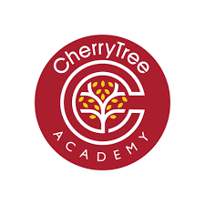
The Quality of Education Subject Pathway


COMPUTING CURRICULUM
Intent
As current school leaders, we know that the jobs of the future have not yet been created. Advances in technology are continuously changing the world we live in. Our computing curriculum combines the acquisition of skills, with the essential knowledge pupils need to act safely online and make informed decisions about the information they handle and share.
The computing curriculum aims to:
- Incrementally develop the skill of coding and programming over the primary journey;
- Teach children how to be safe in the online world;
- Teach digital literacy – searching for information, decided on reliable and unreliable online sources;
- Improve IT capabilities across the curriculum – in writing, maths and art.
The planning, amended from Lion Pathways, maps all objectives from the National Curriculum to ensure that progression is clear from EYFS to Year 6. Lesson plans map the essential platforms and apps for children to work with.
In addition, the curriculum is also mapped with an e-safety curriculum outline that shows the strands required to build digital safety.
Component lessons, in a unit sequence, end with a composite task. These range from:
- Artefact creation – image, audio, video
- Coding and Programming – end of composite unit performance

The scope of the Primary Computing curriculum
We have developed the curriculum by compartmentalising study into three distinct areas:
Computer Science
Information Technology
Digital Literacy

  - Programming
    - Algorithms
      - Coding
      - Systems
      - Creating digital artefacts
        - Understanding digital
footprints
      - Computing uses – locally
and globally
        - Mechanics
        - Searching information
          - E-safety
          - Using IT to enhance our own productivity

Computer science
Children learn about the fundamental concepts of computer science, such as abstraction, logic, algorithms, and data representation. They also learn how to write computer programs to solve problems
Information technology
Children learn how to use information technology to create programs, systems, and
content. They also learn how to evaluate and apply information technology to solve problems.
Digital literacy
Children learn how to use technology safely, respectfully, and responsibly. They also learn how to recognise acceptable and unacceptable behaviour, and how to report concerns about content.

Computing strands mapped against the National Curriculum
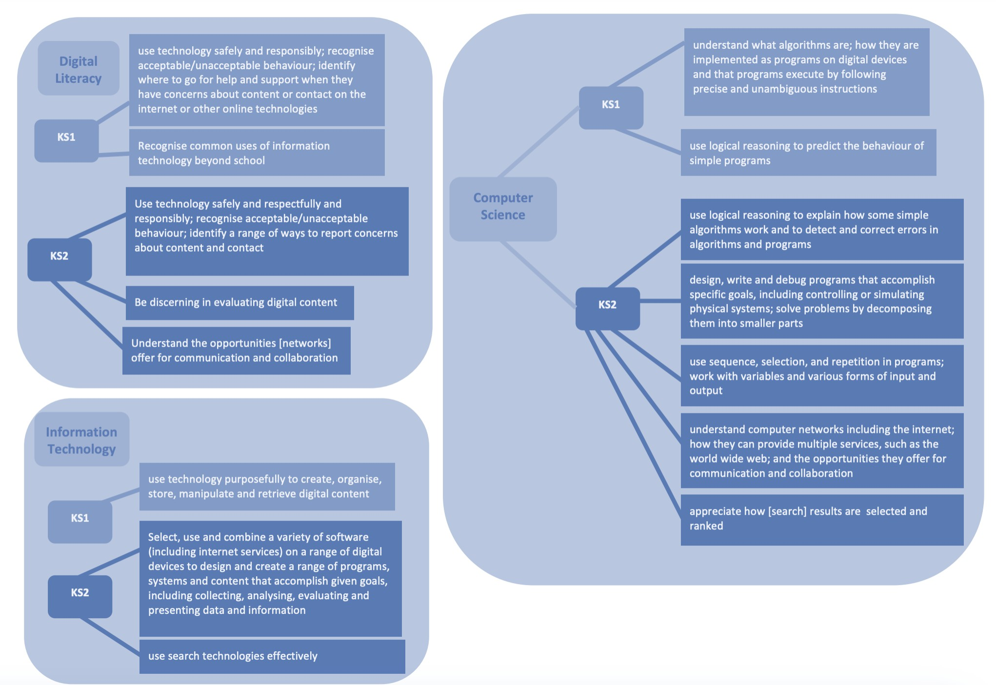
Planning
Throughout our lesson plans and connected lesson visuals, pupils are presented with layered content that builds understanding over time. We know that pupils presented with disconnected information in lessons cannot build fluency or apply the knowledge and skills in meaningful contexts.
Computing planning differs from other curriculum subjects – it lends itself well to interpretative tasks to ensure pupils have a concrete understanding of concepts. For example: Year 3 pupils learning about passwords, role play being ‘the internet’, ‘the email’ and the transportation of the message.

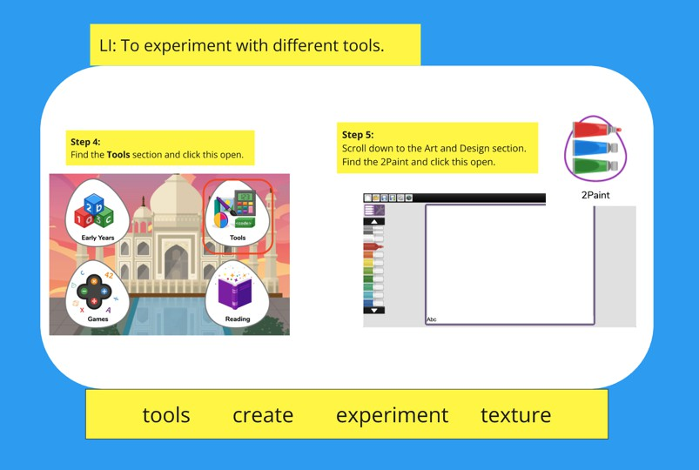
Lesson visuals present pupils with coherent structure and models of the IT software that the child will encounter.

In this MIRO (presentation software) example – Year 1 are looking at 2Simple software and creating pictures/paintings using technology as a medium for expression.
Lessons reinforce key vocabulary as well as the learning intention.

Foundational knowledge – EYFS Computing Pathway:

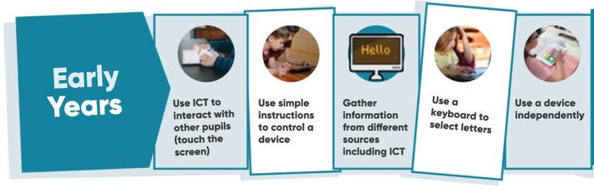
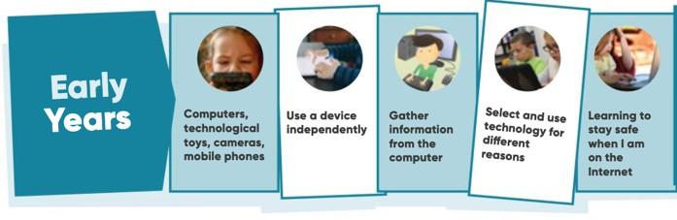
Curriculum delivery for EYFS: E-safety curriculum pathway:
Computing in the Early Years Foundation Stage (EYFS) curriculum focuses on developing basic skills that children need to use a computer or tablet. These skills include:
            - Mouse skills: Learning how to use a mouse
            - Programmable toys: Using toys like Beebots and remote-control cars
            - Cameras and iPads: Taking photographs and recording work
            - Electrical items: Using non-working phones and cameras in role play areas
            - CD recorders: Listening to stories and songs

Language and Vocabulary development in Computing

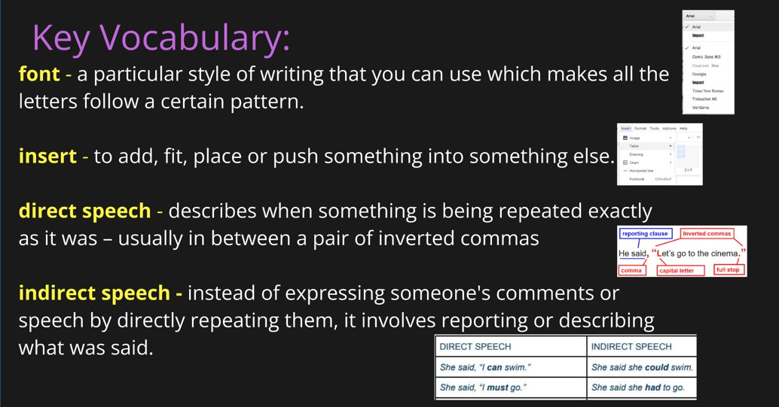
To ensure that pupils can progress, a heavy emphasis is placed on language and terminology study.
Lessons begin with word banks and visual representations to support cognitive understanding.
This is coded so that its consistent in all lessons.

Adaptation of task to support all groups

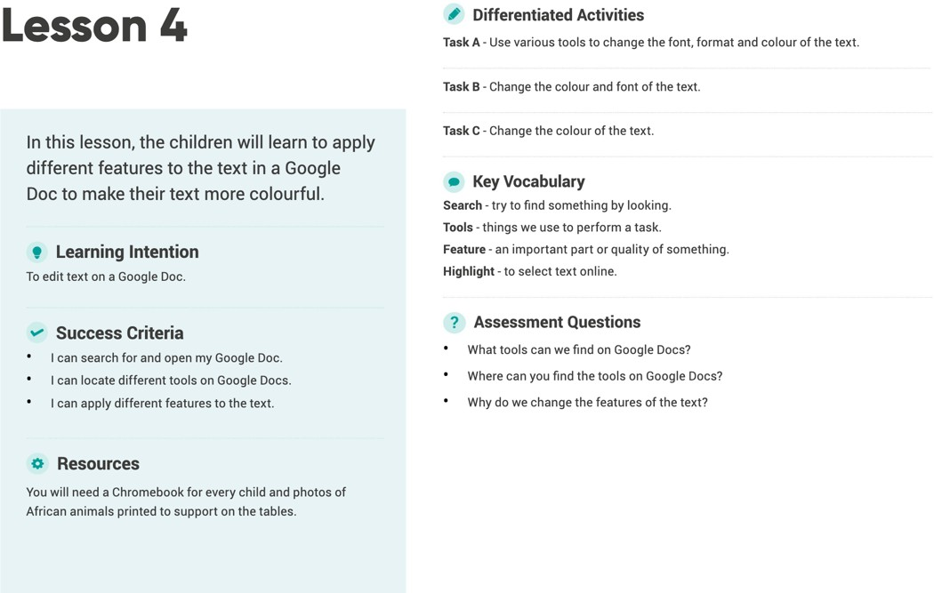
All lessons are sequentially planned to ensure that pupils have carefully ordered study to build schema in Computing over time.
Adapted teaching ensures that pupils of all abilities are catered for in terms of activity to support their learning style.
These adapted tasks link to the learning intention and the success criterion.

Implementation
“Everyone should learn how to program a computer. It teaches you how to think”
Steve Jobs

Experiential learning
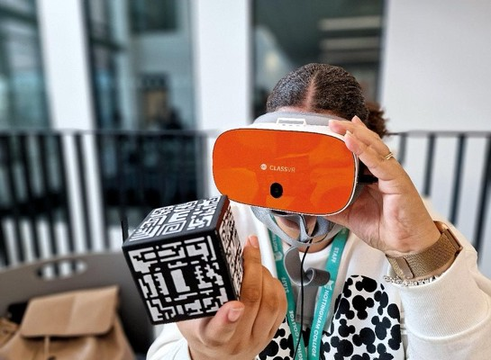
Our school serves a diverse pupil population. With an increasing proportion of children falling into the ‘disadvantaged’ category, our mission is to ensure that irrespective of background or need, we provide pupils with innovative learning experiences that ignite a passion and interest in the subject.
In Computing, we utilise technology to enhance pupils’ contextual learning as well as their knowledge of IT.

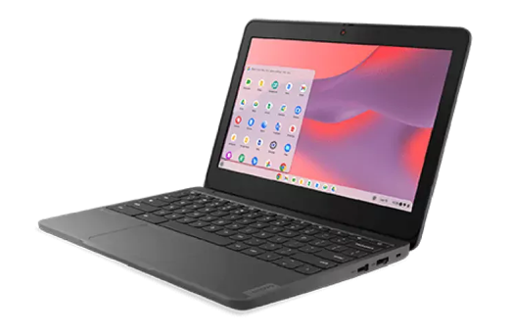
Pupils become familiar with different types of technology throughout their time with us.

All teachers have access to an interactive board – which is used to model, present and support pupils in visually demonstrating their learning.
Children have access to these boards and become familiar with their use – particularly in subjects such as Mathematics where visual
demonstration supports that cognitive understanding of pictorial learning.

Assessing pupil progress in Computing

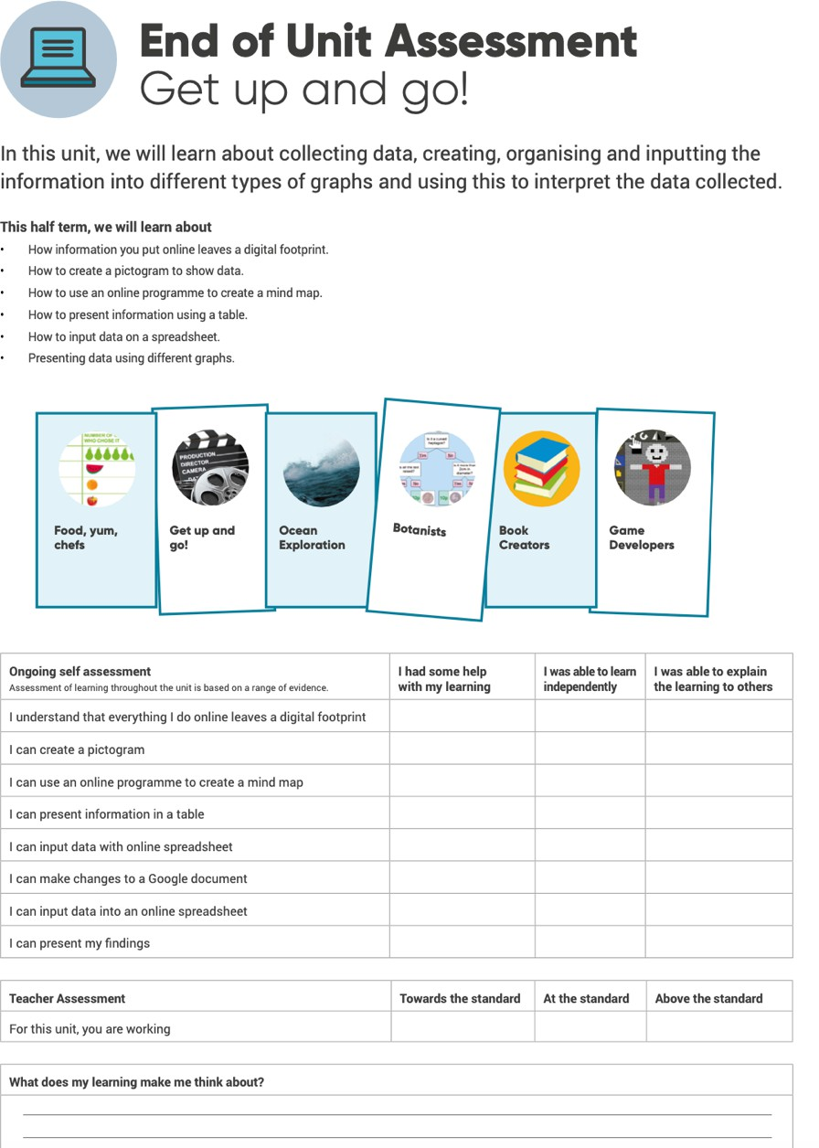

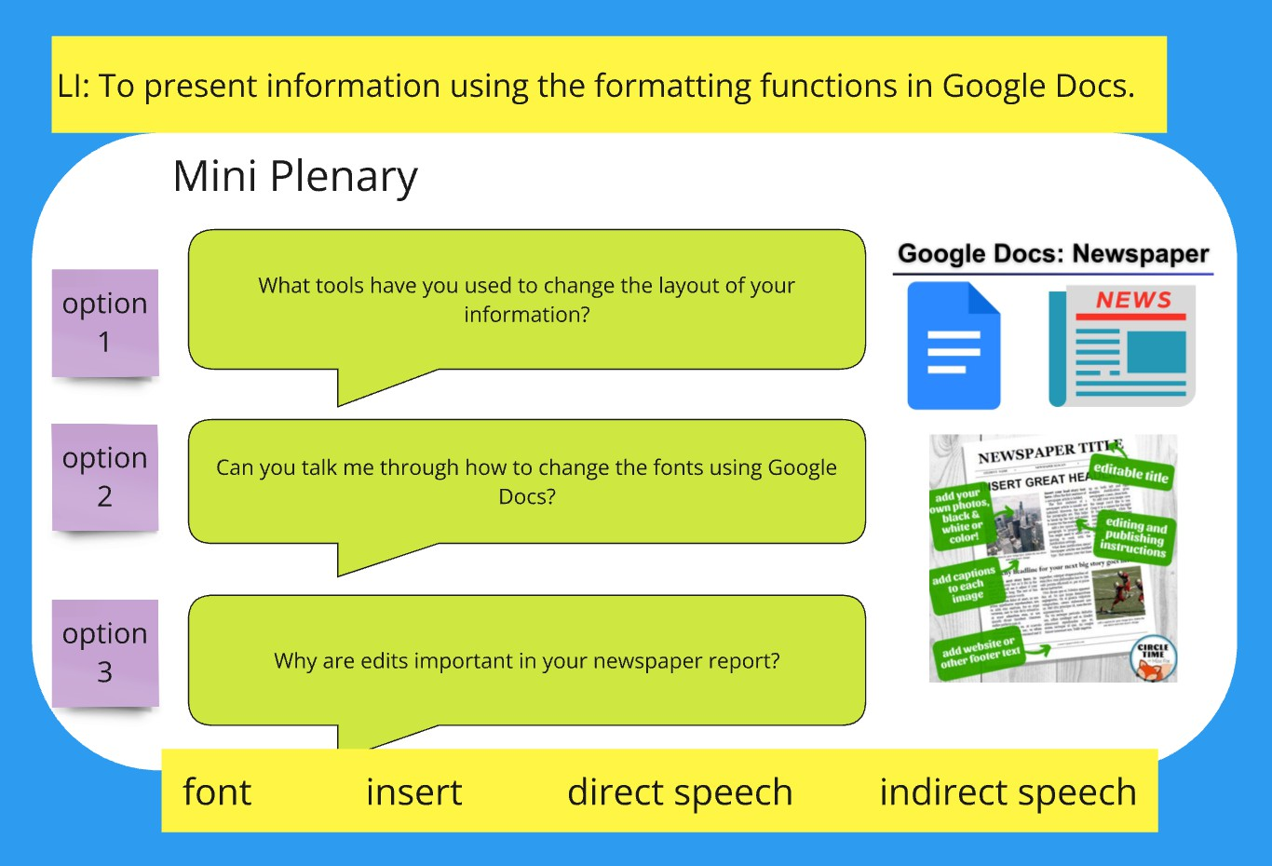
Mini plenaries are continually planned throughout the MIRO boards so that teachers employ formative assessment to unpick whether or not children are accessing and understanding the learning intention set.
This enables teachers to identify and highlight gaps or misconceptions.
Teachers continually employ formative assessment to understand how pupils are knowing more and remembering more.
Each lesson, across the curriculum, begins with re-capping of the previous component lesson. Quick fire questions are answered verbally, in books or in groups.

Quizzes, delivered through IT and plenary activities, further demonstrate the knowledge pupils’ have acquired. This example of low-stakes testing supports teachers in making balanced decisions on when to recap and repeat knowledge to ensure that is fully embedded.
The Lion Pathways provide a composite assessment task at the end of each component unit. This combines pupil self-assessment with teacher assessment indicating how well pupils have progressed in the component unit.

